Working with a Personal Access Token
In a lab setting, where host computes may be used by multiple users, it may not be practical to use personal credentials to access the hobl Git repository. In this case, using a Personal Access Token (PAT) in place of email and password credentials would be preferable. Although a PAT would still be associated with a particular account, it can be shared among the members of a team without compromising security.

Setting a PAT
From the HOBL repository home page you can select the User Settings icon (top right) and then select “Personal access tokens”, as shown in the picture below. Alternatively, you can use this direct link:
https://msftdevicespartners.visualstudio.com/_usersSettings/tokens
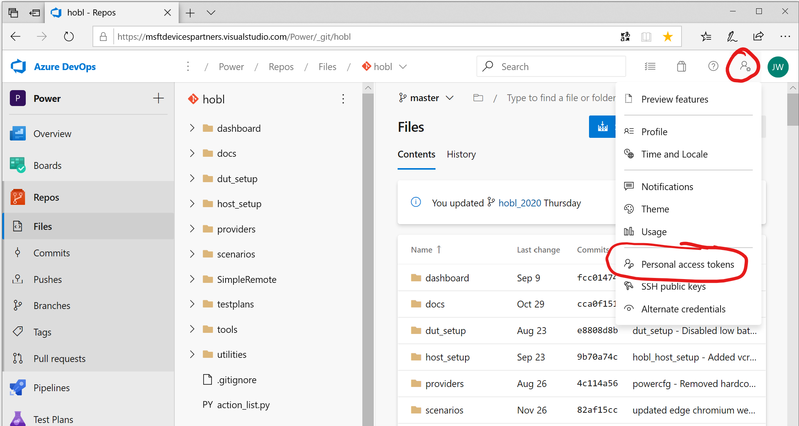
Then select “New Token” to bring up the form. Enter a name for what this token will be used for. “HOBL” is a good choice. Then I recommend extending the expiration, by selecting “Custom” from the drop-down. I believe one year is the maximum. Then select “Read” for all listed scopes. When you click “Create” you will get the lengthy code. Copy and paste that token code to some place secure that can be accessed by the team, because it can’t be retrieved again from the website. When the token expires, you can come back here and click “Regenerate” to renew it for another year.
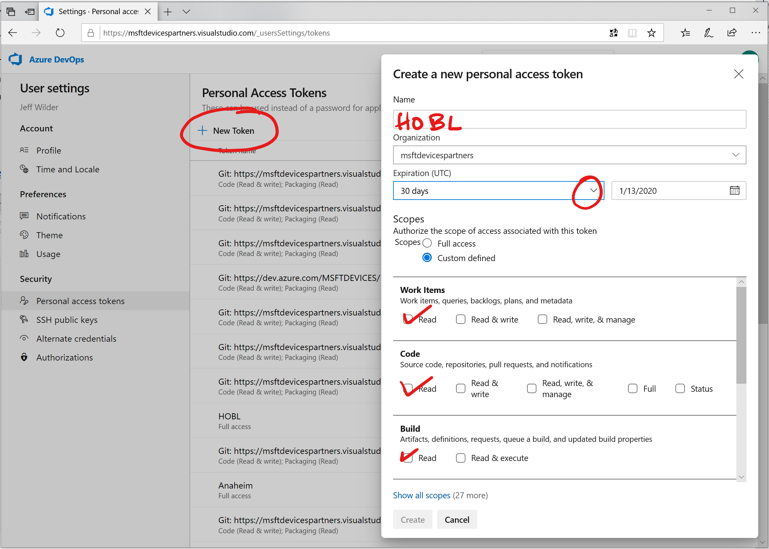

Using a PAT
Whenever prompted for a username by Git, you can paste the PAT code. You should get access without being prompted for a password.

